3D Printable Water Release Instructions:
Printing, Assembly, and Rigging
Most Important Points (TL;DR)
- Print the pin horizontally with a solid infill
- Print in ASA
- Plastic part of the starch bobbin faces the spring during assembly
- Must be rigged in double shear (untested in single shear)
- Attach recovery line to the holes in the screw so it can be reused!
Printing
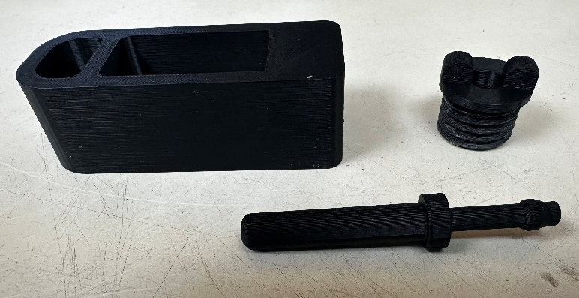
The stress-tested version of this water release was printed on a Stratasys Fortus 450mc with a T12 tip in ASA Black material, a petroleum-based plastic with a relatively high melting point. The frame and screw were printed with double-dense infill and sparse support (SR30 material) oriented with the flat side down. Note that support material is not necessary for this design. After printing, the threads in the frame may need to be chased with a 15/16 – 9 tap (a 7/8 – 9 tap will work too). The pin was printed with solid infill and sparse support (SR 30) and oriented horizontally on the print bed – this is very important for the structural integrity of the pin. The prints can be put in a cleaning bath after printing to remove the SR30 support material. This makes cleaning up prints much easier, especially in large batches.
Figure 1: Orientation for printing parts.
Note that using other materials, printers, print orientations, and even colors can change the strength of the water release. The release as described above was tensile tested to breaking at 684 lbs. The test was conducted on the Chant tensile testing machine at the WHOI wire pool with the release set up in double shear: two bights around the pin on one side, and one on the other.

Assembly
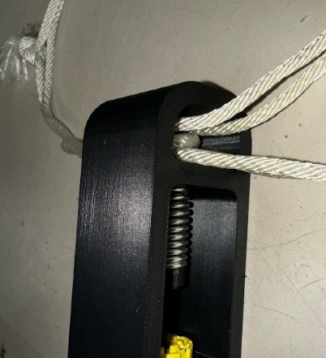
The release is designed to be used with a steel compression spring (1.5” long, 0.5” OD, 0.376” ID, from McMaster-Carr) and a Halkey-Roberts starch bobbin (V80040). When assembling the release, place the starch bobbin such that the side showing yellow plastic tabs faces towards the spring.
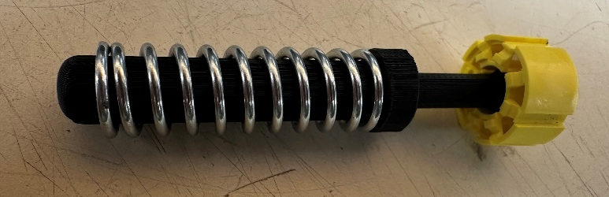
Figure 2: Orientation of the starch collar relative to the pin.
Rigging
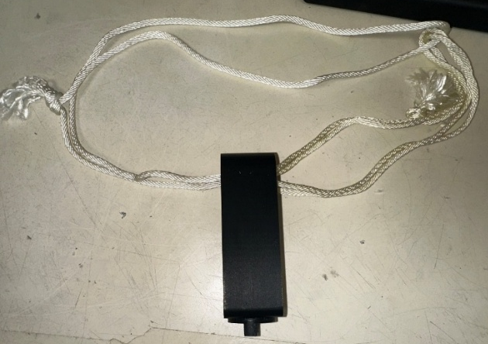
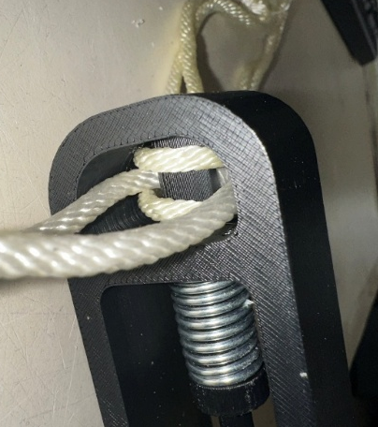
The release should be attached to the straps around the float box with two loops of line, one made from a 46-inch length of ¼-inch solid braid Nylon #6 rope and the other from a 16-inch length of the same rope. Create each loop with an overhand knot so they are secure. Thread the large loop, folded in half with the knot somewhere in the middle, through the loops of all straps at the bottom of the box. You should end up with two bights. Thread the small loop, also folded in half with the knot in the middle, through one of the bights. Now, grab the water release. Put one bight from the small loop over the pin, then put the bight from the large loop on the other side over the pin, and finish with the other bight of the small loop over the pin. Thread the screw part of the piece all the way in, ensuring that the pin doesn’t pinch any of the line. You should have two bights around the pin on one side and one on the other. This balances out the forces on the pin so there is less force on the frame, which is not a solid print like the pin. It also allows the release to take a higher load.
Figure 3: Rigging the water release in double shear.
Thread about a 12-inch length of 2mm blind rope through the two holes on the screw of the release and secure with a knot, leaving most of the line as a tag end. Take the tag end and thread it through both the large and small loops of line and a loop of one of the yellow straps. Secure with another knot. This will ensure the release can be recovered with the straps.
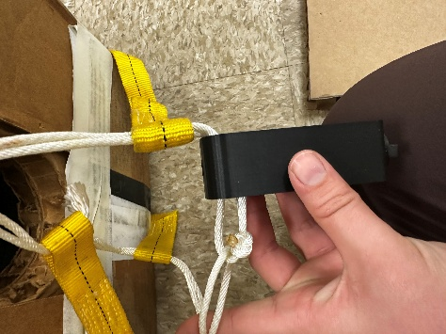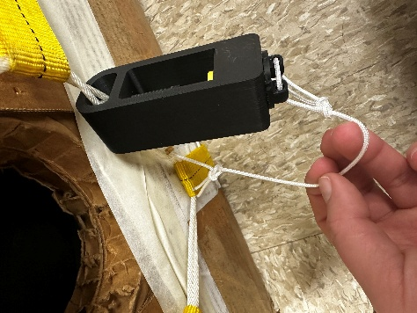
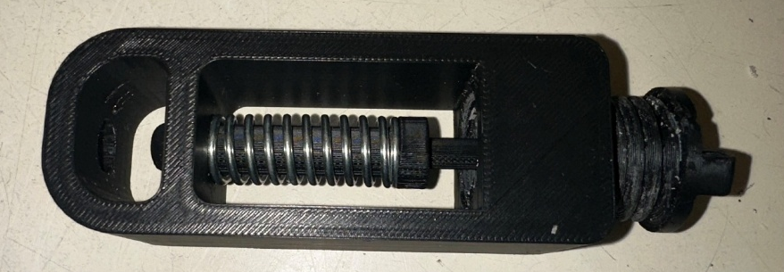
Figure 4: Securing the release to the deployment box.
Figure 5: The water release unprimed (top) and fully primed (bottom).
Cost
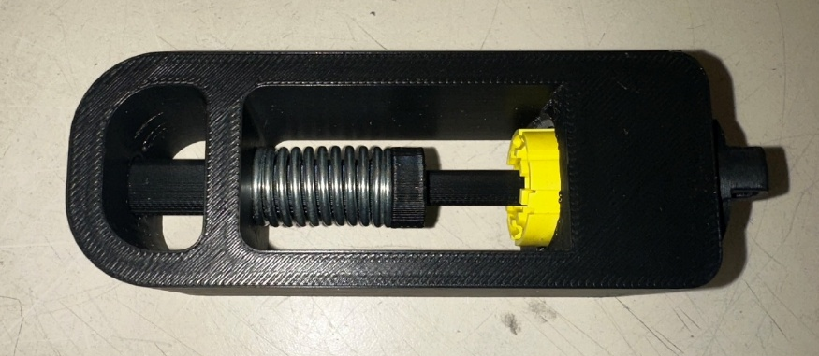
Each 3D printable water release with these specifications uses 2.70 in^3 of model material and 1.40 in^3 of support material which costs $22.65 (as of 2025, if made individually at WHOI). A batch order print online is significantly less expensive. Each spring costs $1.19 from McMaster-Carr.

